General tips for the Task below.
Task Title
CloudTrail, SNS and CloudWatch
Objective
Worked on pre-requisite, as I watched the Monitoring video posted in DevOps group in slack and task to work on CloudTrail, SNS and CloudWatch.
Enable AWS CloudTrail monitoring and configure delivery of audit logs to Amazon S3 and CloudWatch Logs for secure storage, analysis, and real-time monitoring.
Prerequisites
List all requirements before starting:
- CloudTrail monitoring
- AWS account
- s3 storage
- SNS for CloudTrail
- CloudWatch monitoring

Issues Faced: Briefly mention issues and how you fixed them. Posted below in the last.
Conclusion
Write 1–2 lines summarizing that the task was successfully completed.

- Enable CloudTrail monitoring and store the events in s3 and CloudWatch log events.

- Creating new CloudTrail monitoring and store logs in s3.
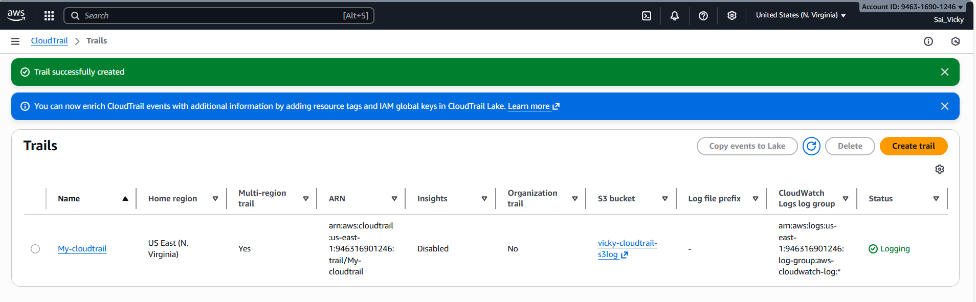
- Created CloudTrail monitoring with events in S3 and CloudWatch both.
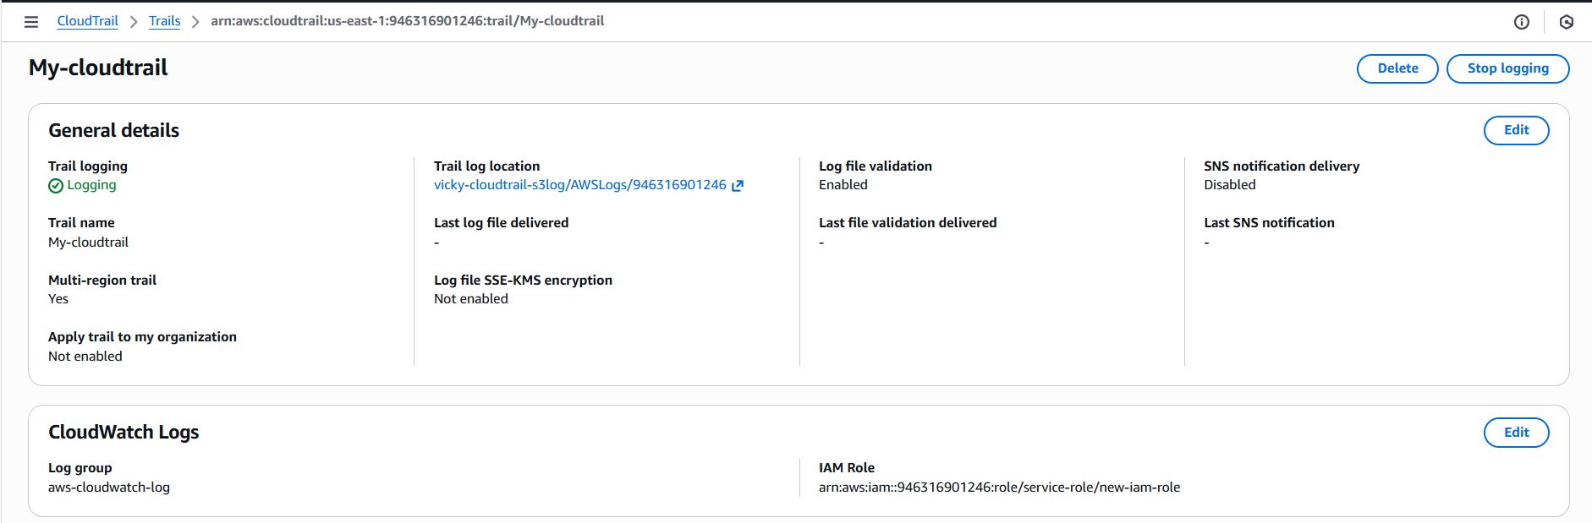
- Once CloudTrail created, we can see the logs are created in S3 bucket.
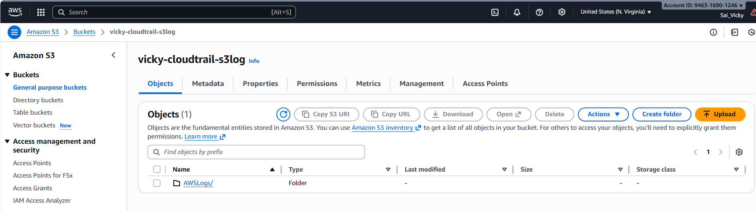

- Once CloudTrail created, we can see the logs are created in CloudWatch.
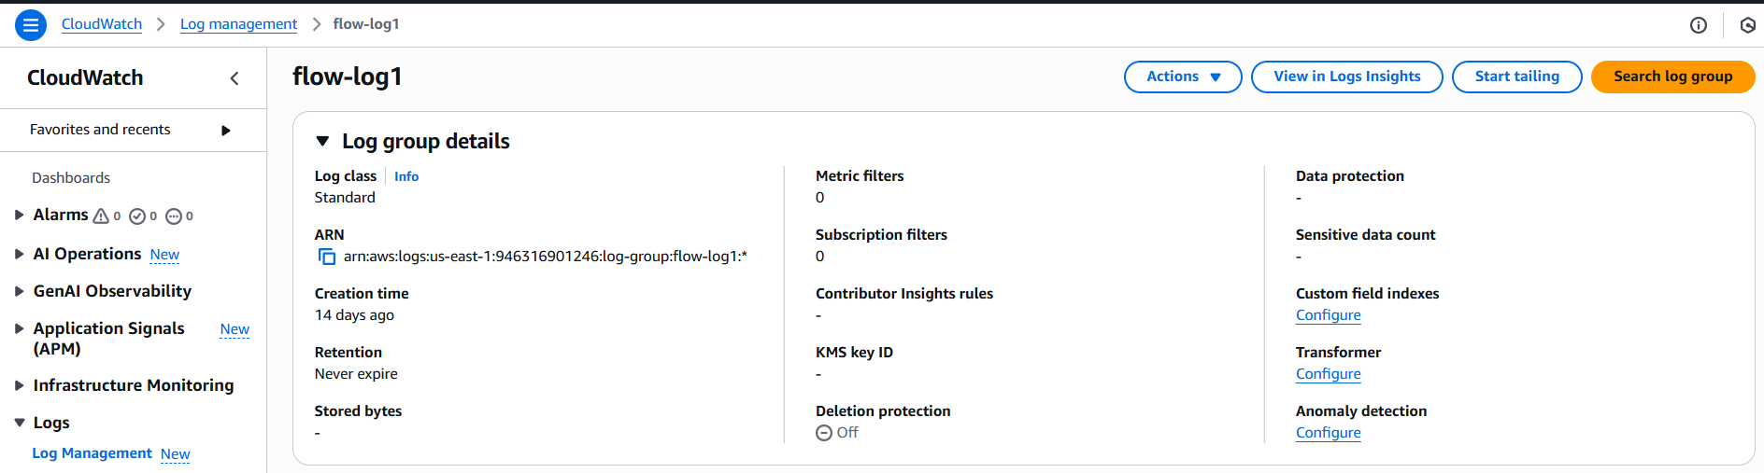

- Enable SNS for CloudTrail to send alert on email.

- Navigated to SNS services in AWS.
- Created a new topic in SNS named- My-SNS-topic
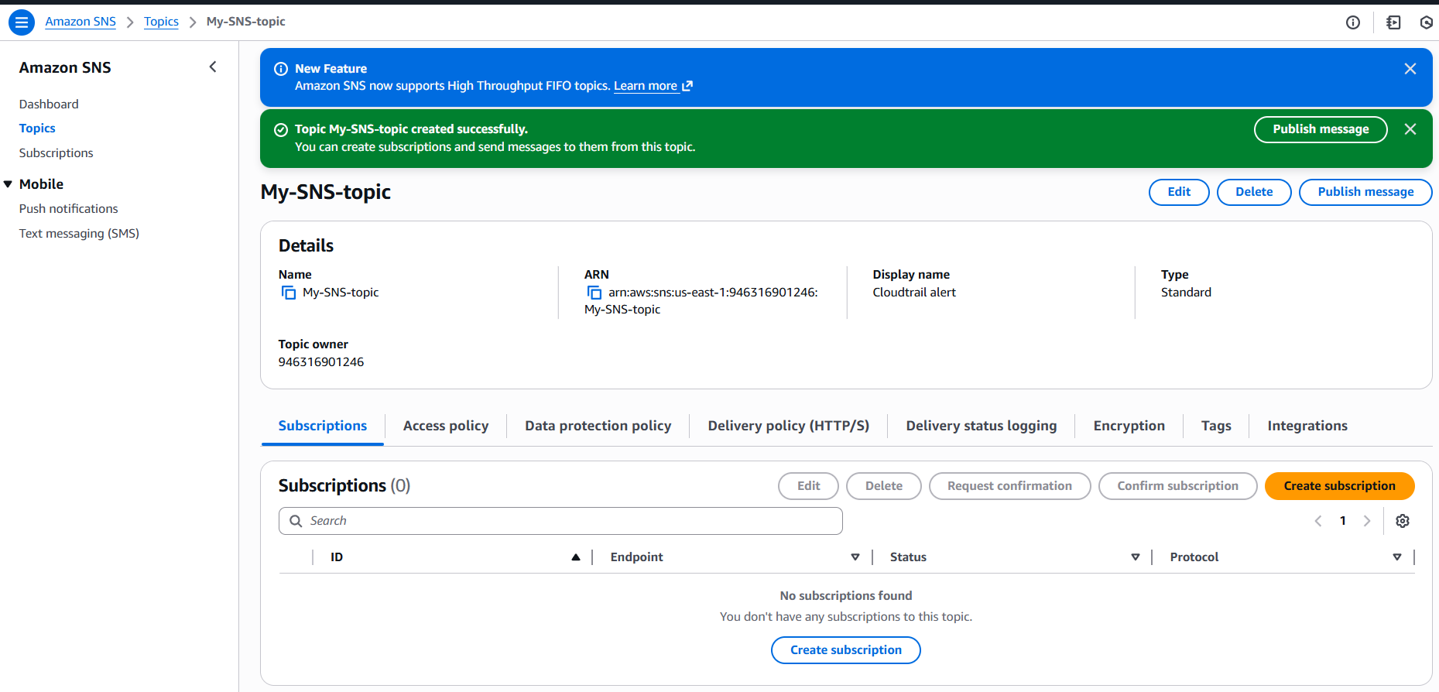
- Now, we need to provide subscription to the SNS, what kind of alerts are required.
- Here, we are creating e-mail alert for this task, whereas in future, we can modify or create an alert that’s required as per requirement.

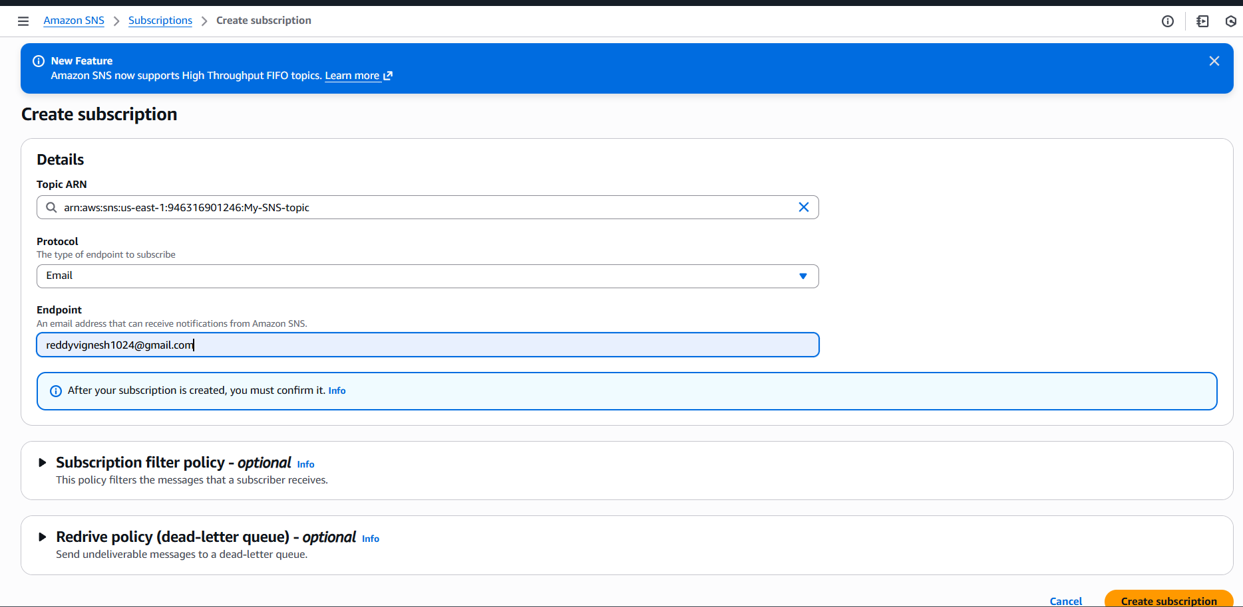
- Finally, a subscription has been created in SNS and email alert confirmation is triggered.
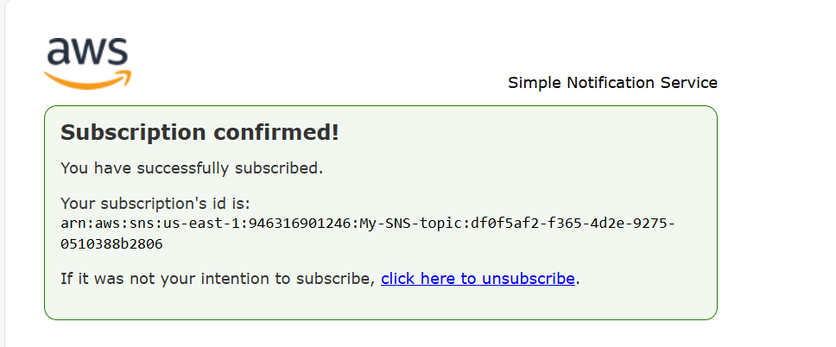

- Now, we can see, once email subscription is confirmed, we can see a topic subscription is enabled.
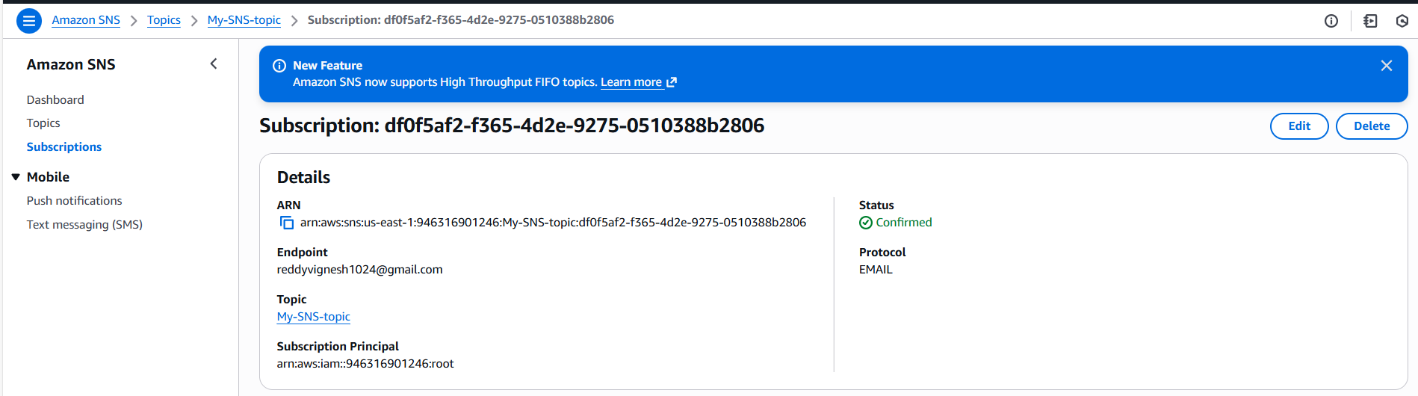

- Now, lets create a CloudTrail and attach the SNS created for email alert to get the alerts from CloudTrail logs.
- Selected S3 bucket to store the alerts.
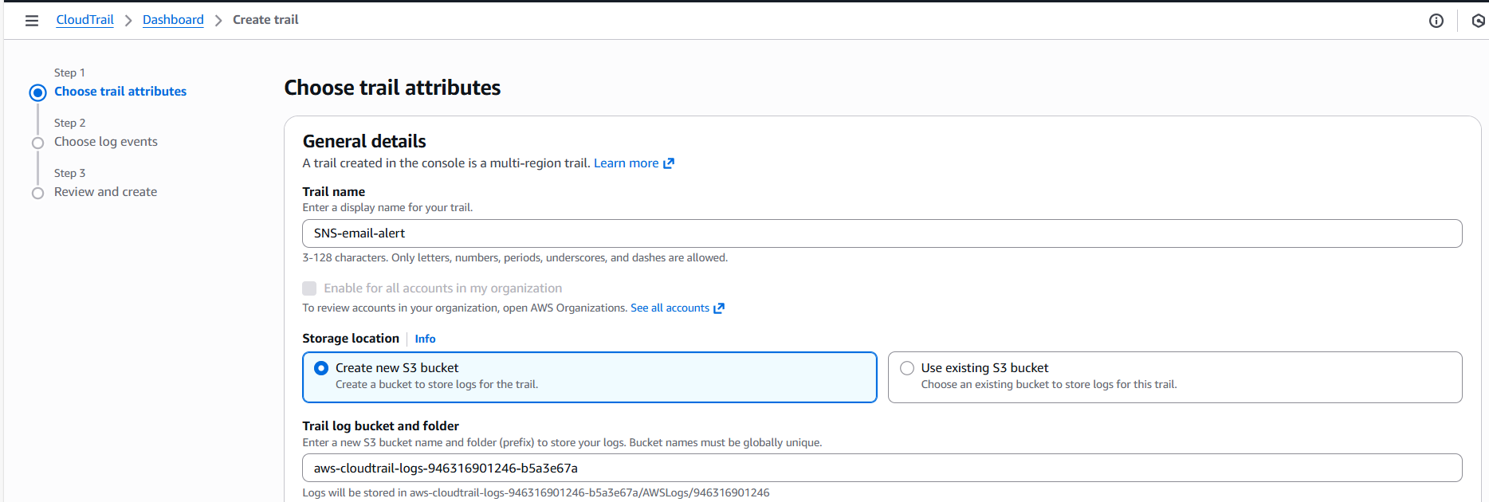
- We can see the SNS topic created prior is available now to link with CloudTrail.
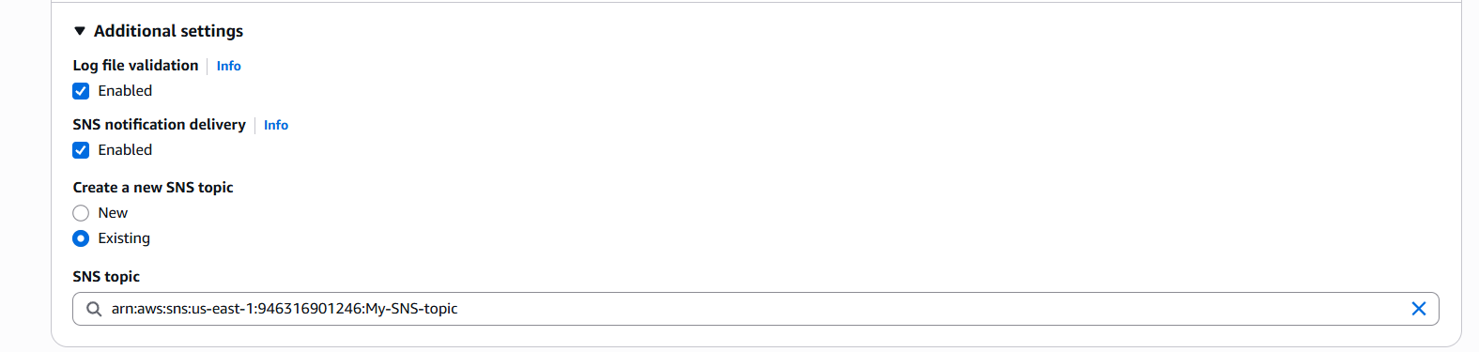
- Created new CloudWatch as well to create logs.
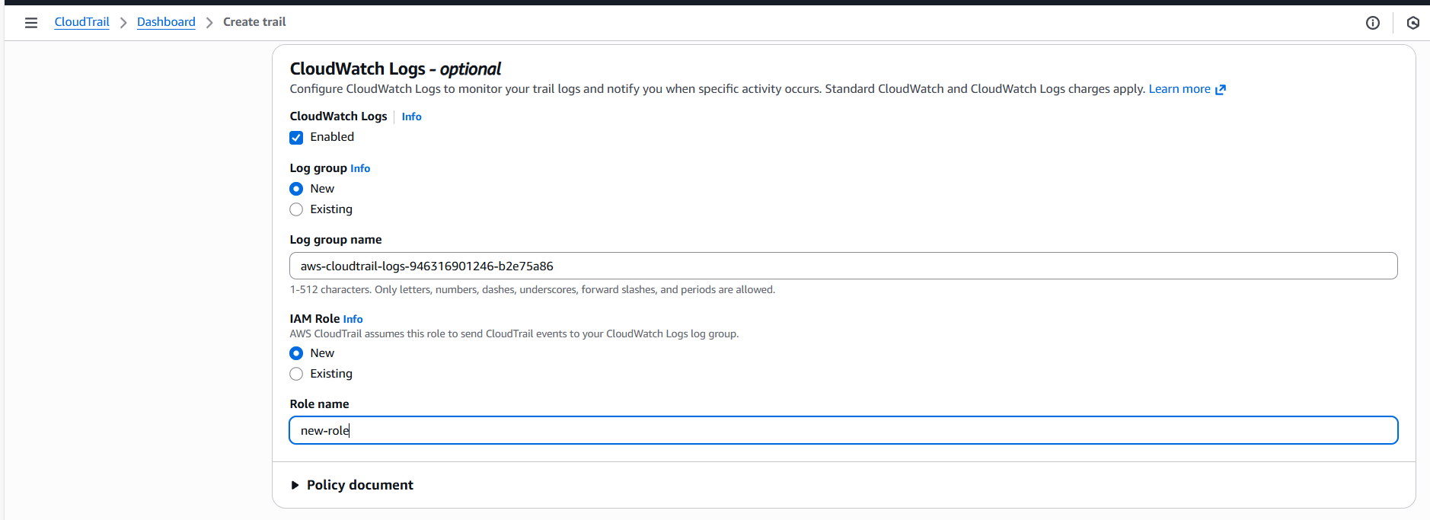
- A CloudTrail has been created with SNS.
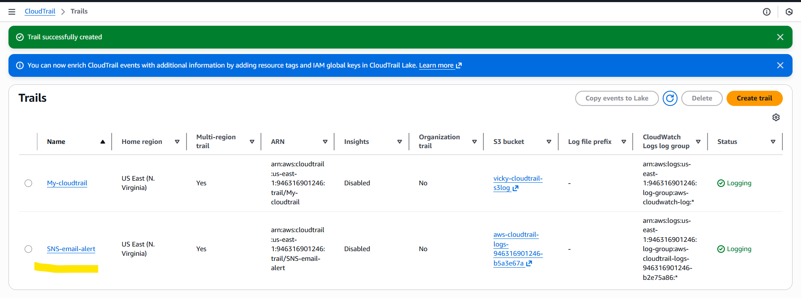

- The below are our CloudWatch logs created with SNS.
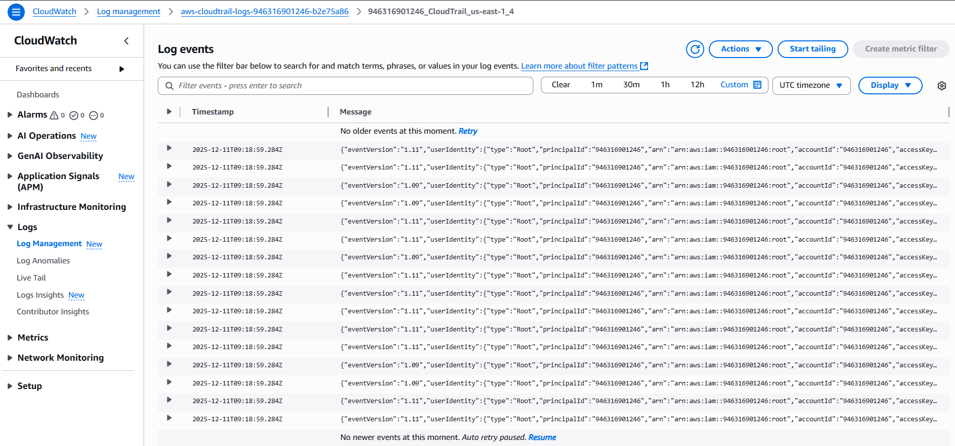
- AWS SNS alert is activated and alerts received.
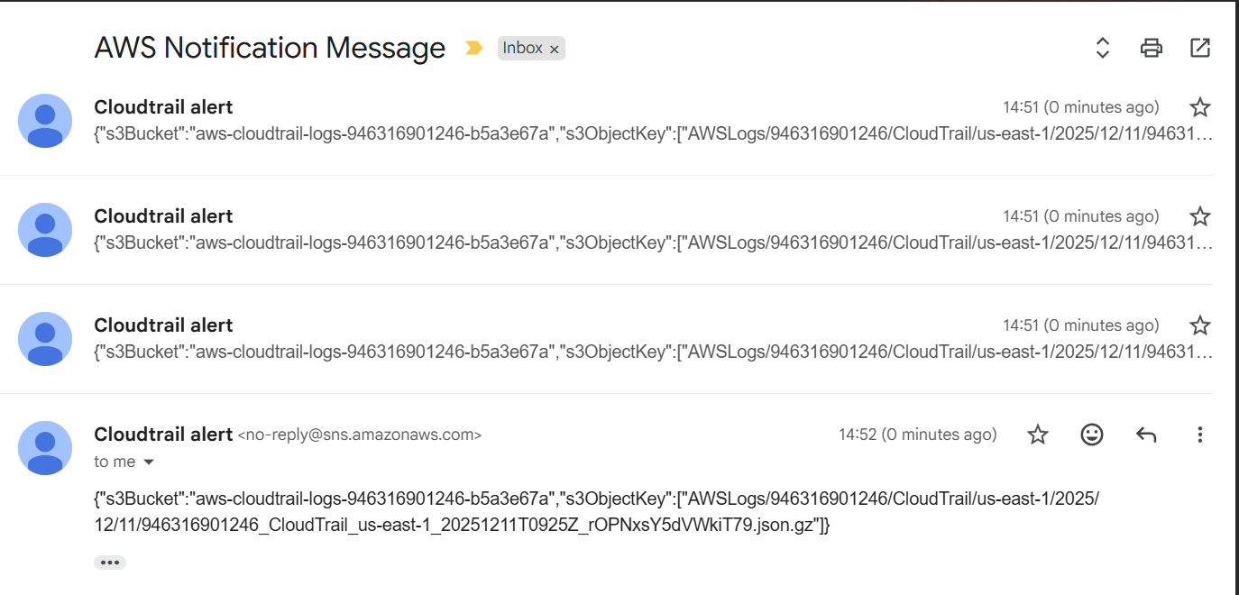
- Task completed.

- Configure cloud watch monitoring and record the CPU utilization and other metrics of ec2.

- As per the AWS records ec2 Metrics automatically. We need to enable detailed monitoring, plus watch the metrics.
- 1st step: Let’s launch a ec2 metrics and monitor the instance for CPU utilization.
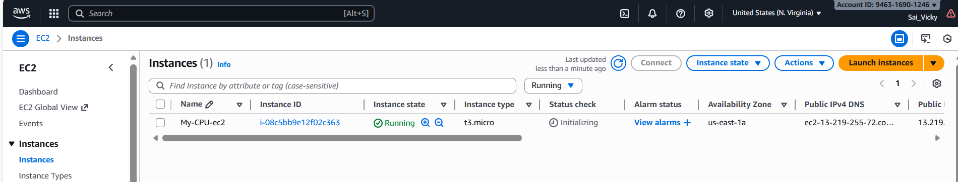
- For that, we need to select the instance monitoring and manage detailed monitoring.
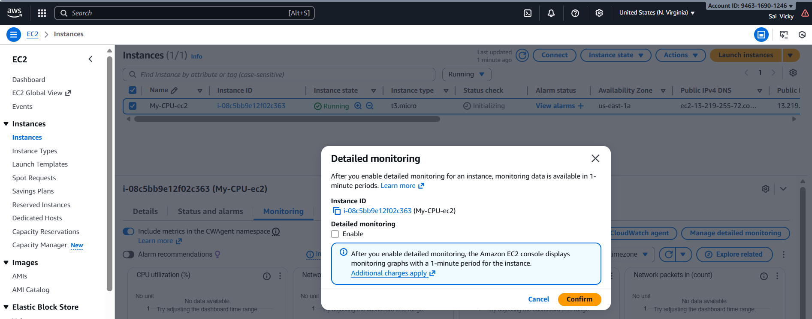
- We enabled “Managed Detailed monitoring”.
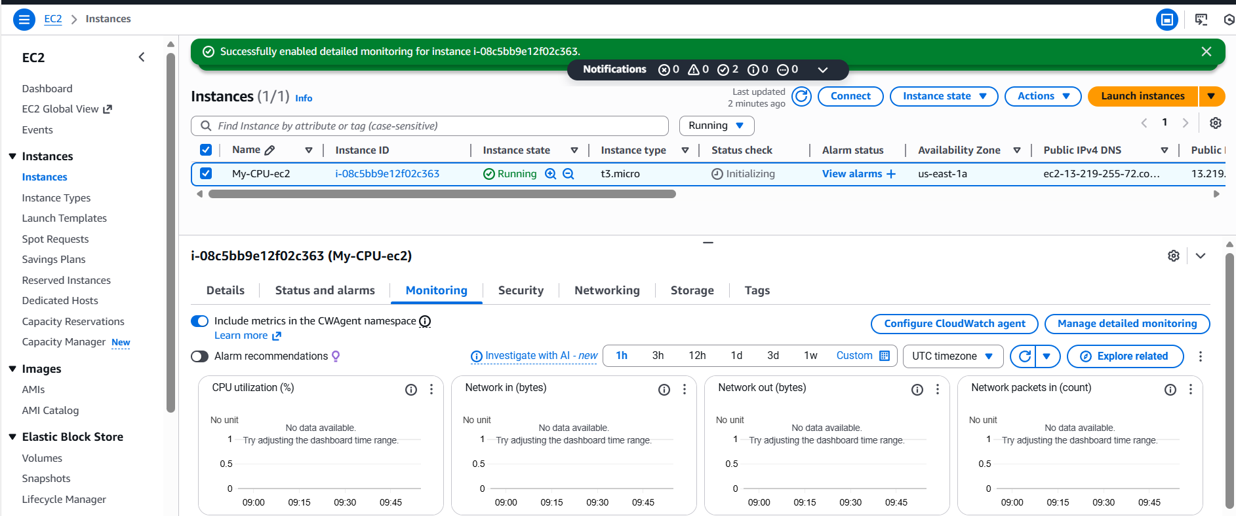

- Final step is to add some load to view the CPU utilization. After adding any service inside ec2, we need to check the monitoring of CPU.
- Added some fake load by connecting to the ec2 instance with command- yes > /dev/null &.
- By adding some fake load, we might be able to see the CPU utilization above certain percentage to confirm if the CloudWatch is working perfectly fine.
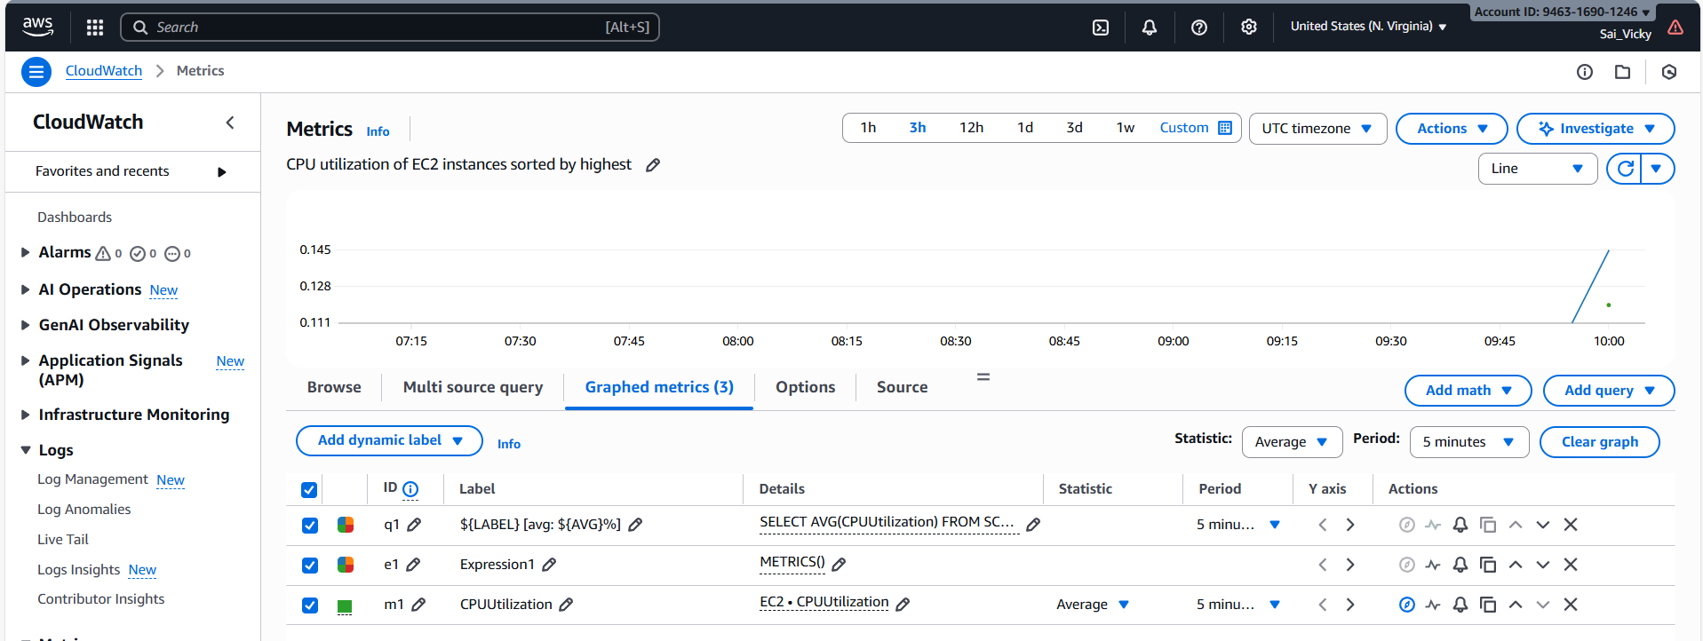
- Create a custom Dashboard with Number- percentage.
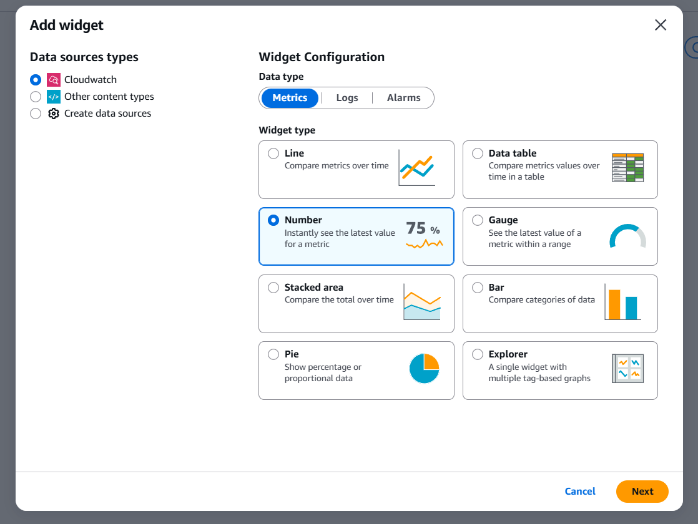
- Using Top command- verified how much percentage did ec2- CPU utilization used.
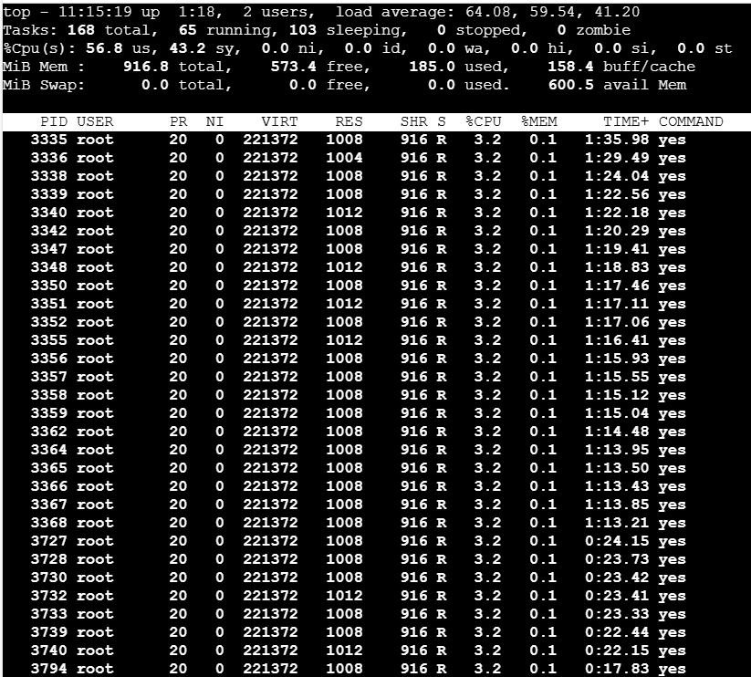
- Create one alarm to send alert to email if the CPU utilization is more than 70 percent.
- Let’s begin creating alarm as 1st step.
- Navigate to alarm and create one.
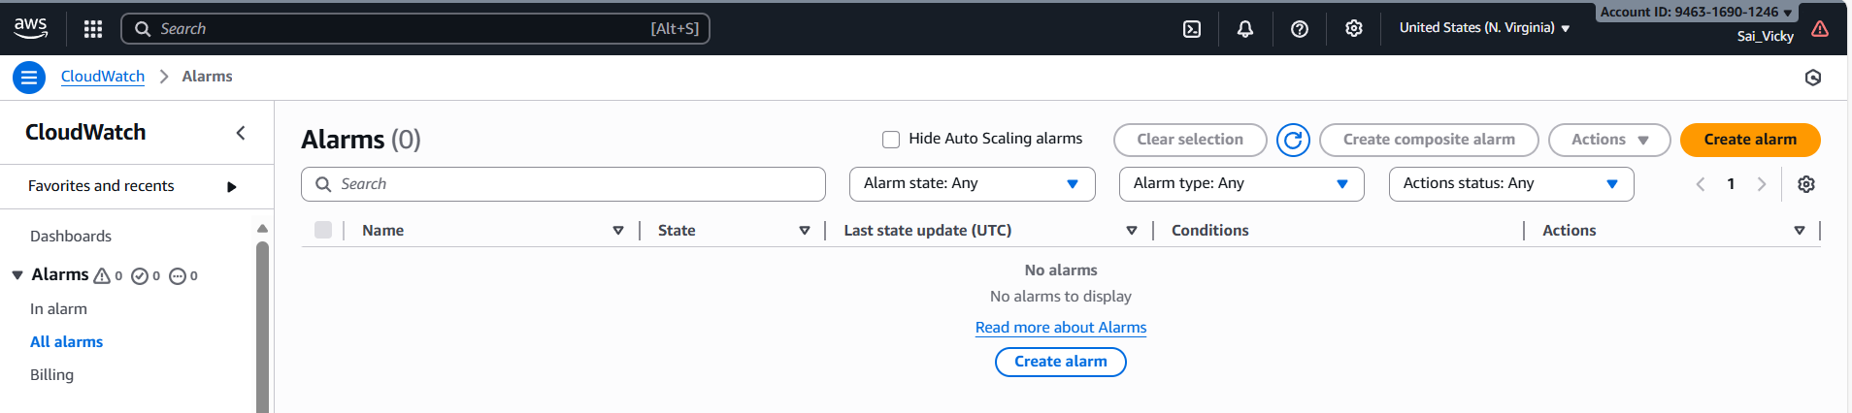
- Select ec2 from metrics.
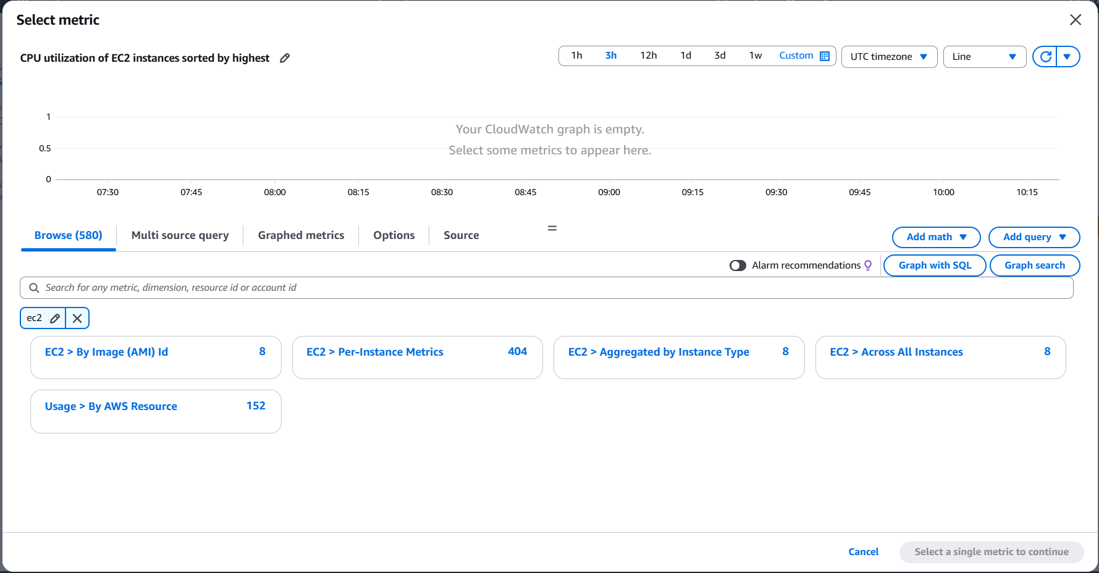
- Setting up an in alarm for SNS notification to get alerts on Gmail.
- Selected an existing SNS topic.
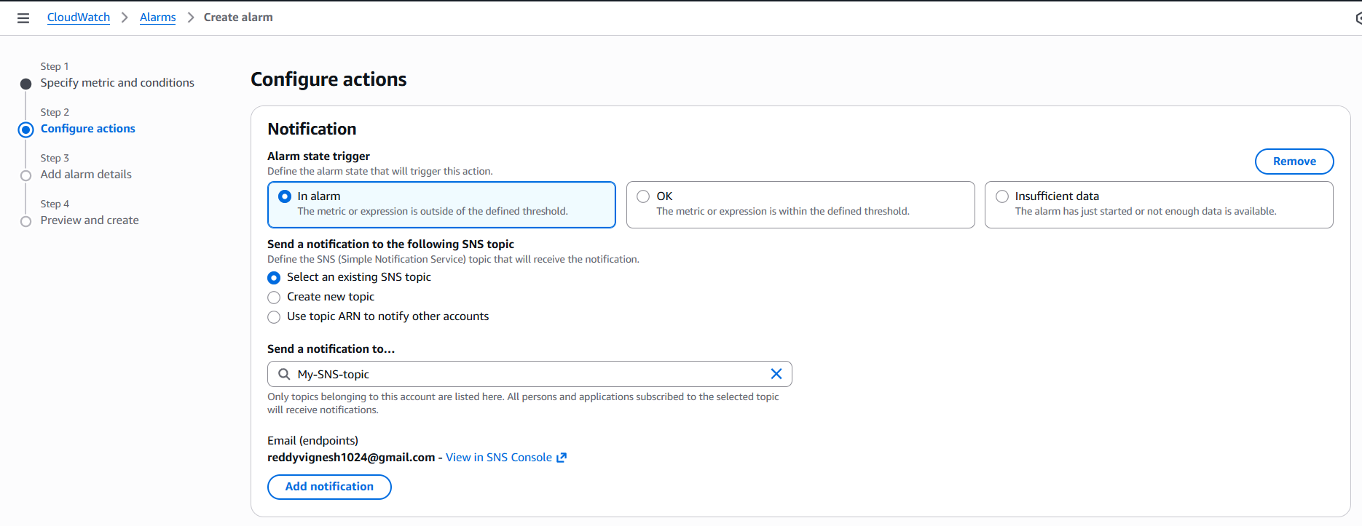
- Named the alarm according to the task- Monitoring alert.
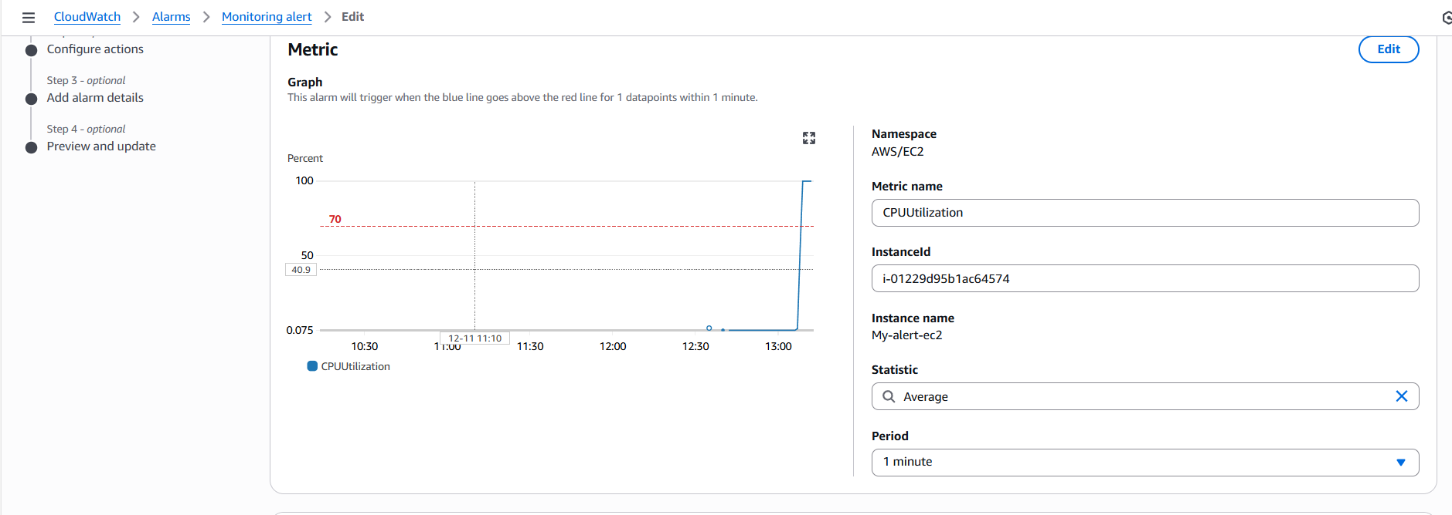

- Condition for the CPU- utilization is set when “Greater than 70%”
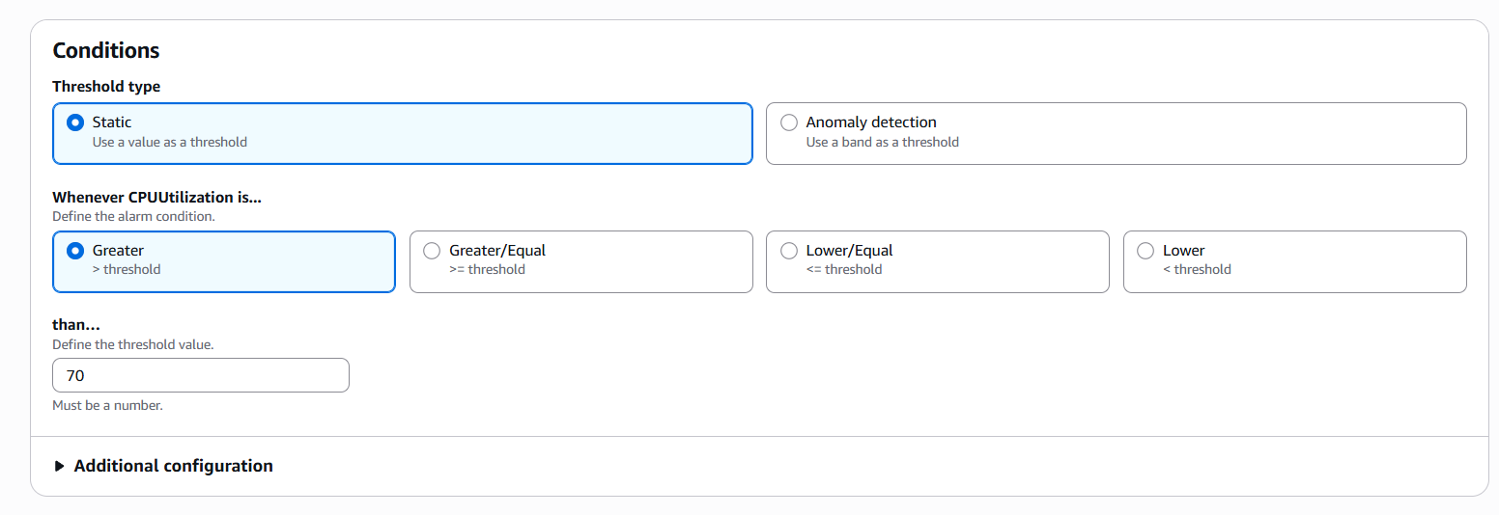
- Selected existing SNS alert with email alert.
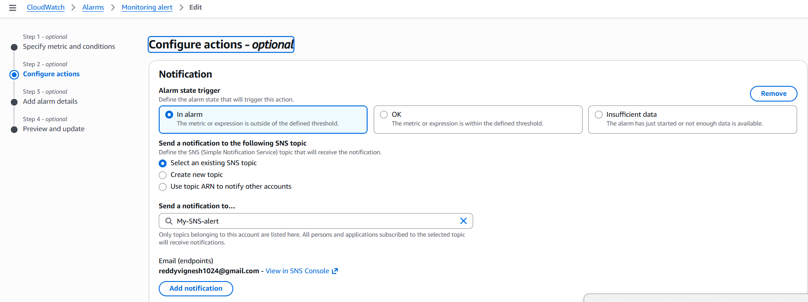
- Created alarm successfully.
- Connected to the ec2 instance and faked CPU utilization. Immediately, we received alarm alert in CloudWatch and received an SNS alert to my email (attached below).
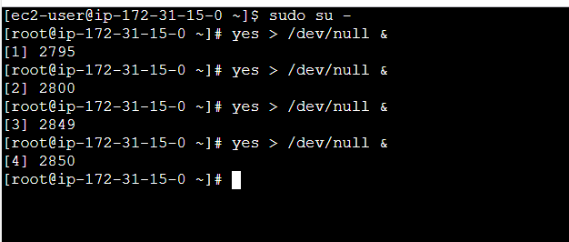
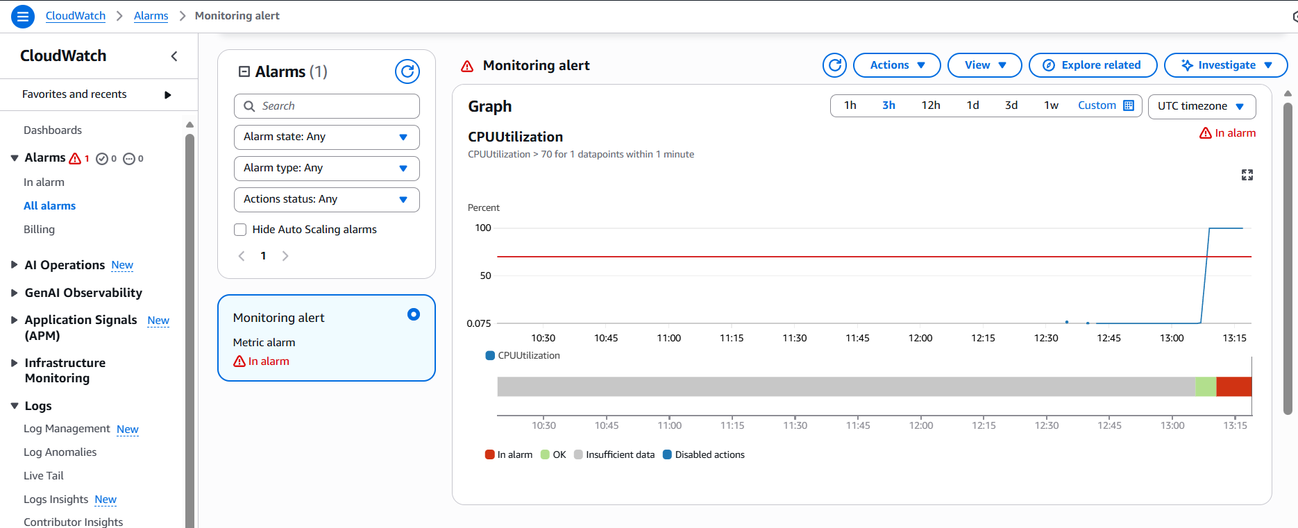

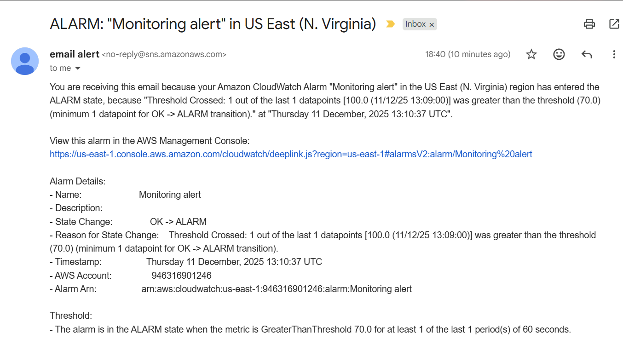
- Task Completed.

- Create Dashboard and monitor tomcat service whether its running or not and send the alert.

- Launched a new ec2 named- Tomcat-ec2.
- Connect to ec2 console and install packages using command- sudo yum update -y and install java using command- yum install java -y command.

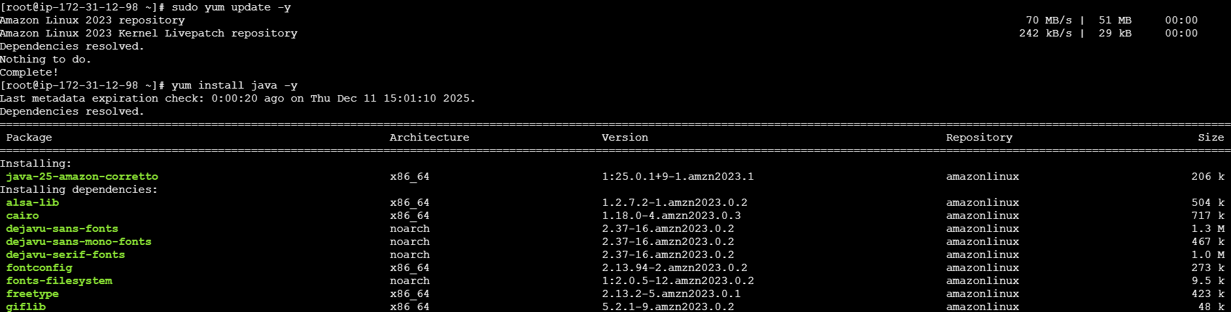
- Install Tomcat by using wget command and execute.
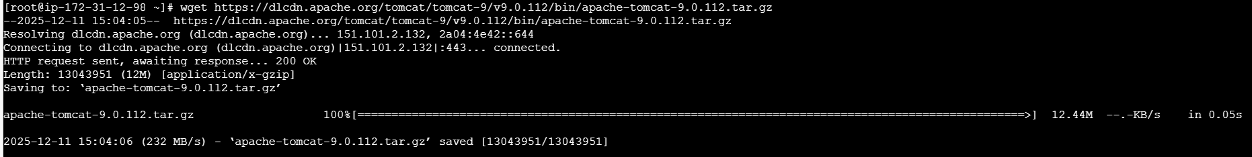
- Extract the file using tar xvf command
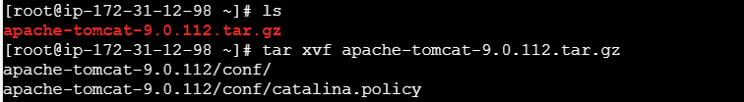
- Now cd to apache-tomcat
- Now cd to bin and execute Tomcat to start
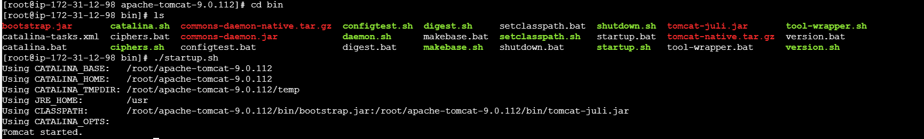
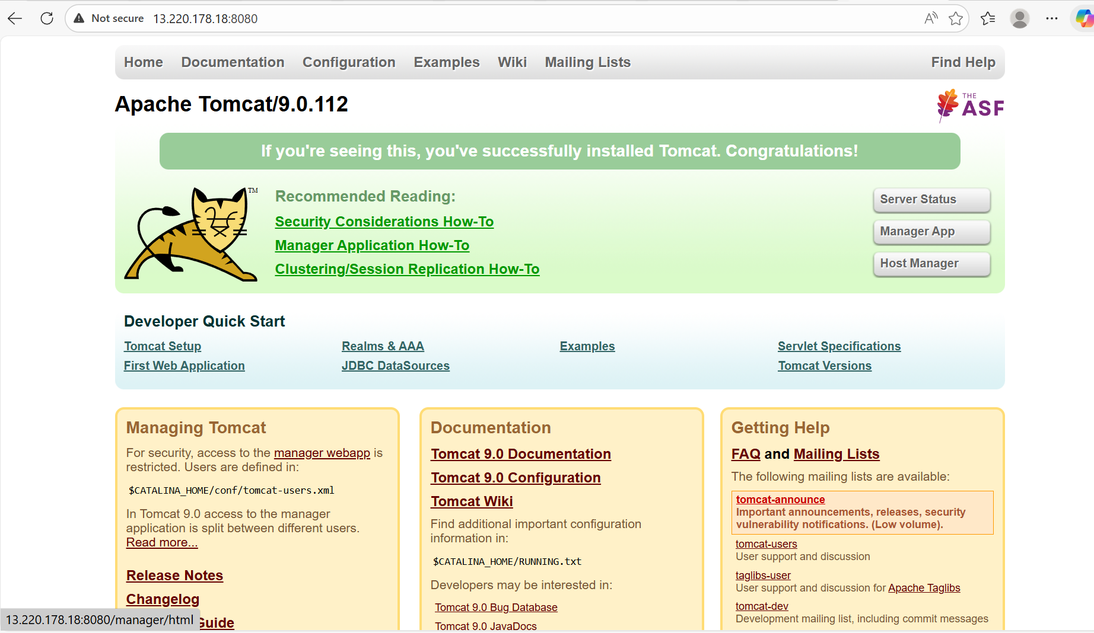
- Created a directory- Scripts and configured aws credentials. Before creating this directory. Cd /opt/bin, this is where the tomcat file is present.
- Once Tomcat started and executed the script under Directory- “Scripts”. It showed as 1.
- The scripts is below.

#!/bin/bash
# ===== Configuration =====
REGION="us-east-1"
TOMCAT_PATH="/opt/tomcat"
NAMESPACE="tomcat"
METRIC_NAME="tomcat_status"
# ========================

# Get Instance ID (Supports IMDSv2 and IMDSv1)
get_instance_id() {
IMDS_HOST="169.254.169.254"

# try IMDSv2
TOKEN=$(curl -s -X PUT "http://${IMDS_HOST}/latest/api/token" \
-H "X-aws-ec2-metadata-token-ttl-seconds: 21600" --max-time 5)

if [ -n "$TOKEN" ]; then
INSTANCE_ID=$(curl -s -H "X-aws-ec2-metadata-token: ${TOKEN}" \
"http://${IMDS_HOST}/latest/meta-data/instance-id" --max-time 5)
else
# fallback to IMDSv1
INSTANCE_ID=$(curl -s "http://${IMDS_HOST}/latest/meta-data/instance-id" --max-time 5)
fi

echo "$INSTANCE_ID"
}

# Check if Tomcat process is running
# - By default we match the TOMCAT_PATH (works for /opt/tomcat)
# - If Tomcat was installed differently, we fall back to searching for 'catalina' or a java process on :8080
check_tomcat_status() {
# 1 = running, 0 = not running
if pgrep -f "$TOMCAT_PATH" >/dev/null 2>&1; then
echo 1
return
fi

if pgrep -f catalina\.sh >/dev/null 2>&1; then
echo 1
return
fi

# check if anything is listening on 8080 (common Tomcat port)
if sudo ss -tulpn 2>/dev/null | grep -q ':8080'; then
echo 1
return
fi

echo 0
}

# Publish metric to CloudWatch
publish_metric() {
local instance_id="$1"
local value="$2"

# require aws cli installed
if ! command -v aws >/dev/null 2>&1; then
echo "ERROR: aws CLI not found. Install and configure AWS CLI or attach an instance role with permissions."
return 1
fi

aws cloudwatch put-metric-data \
--region "${REGION}" \
--namespace "${NAMESPACE}" \
--metric-name "${METRIC_NAME}" \
--value "${value}" \
--unit Count \
--dimensions InstanceId="${instance_id}" \
|| return 2

return 0
}

# Main
INSTANCE_ID=$(get_instance_id)
if [ -z "$INSTANCE_ID" ]; then
echo "ERROR: Could not determine instance ID."
exit 1
fi

VALUE=$(check_tomcat_status)
TIMESTAMP=$(date -u +"%Y-%m-%dT%H:%M:%SZ")

echo "${TIMESTAMP} - Instance:${INSTANCE_ID} - Tomcat running? ${VALUE}"

if ! publish_metric "$INSTANCE_ID" "$VALUE"; then
echo "ERROR: failed to publish CloudWatch metric"
exit 2
fi

exit 0
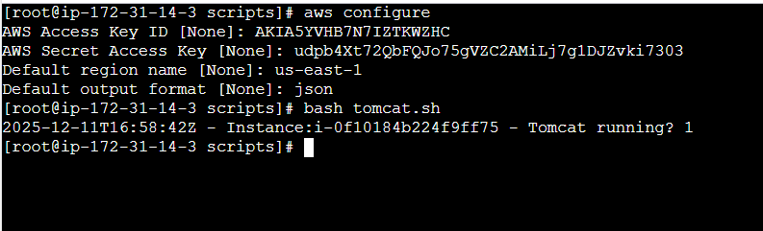
- Again, cd to opt/bin and stopped the tomcat using command- ./shutdown.sh.
- Then cd to scripts and ran the script and now, we can see the Tomcat running is 0.
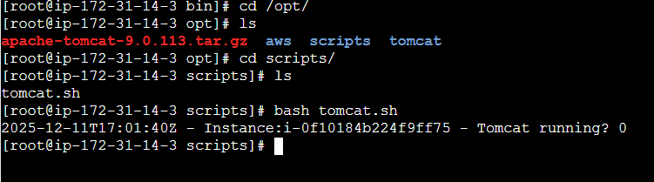

Error faced while working on CloudTrail, CloudWatch and SNS.
- There were few errors and runtime latency while logs were recorded in S3 or SNS alert that were supposed to be on real time.

- 1st error: The time to receive the logs and the latency in collecting the logs were not in real time and delay in logs getting recorded.

- 2nd error: While alarm is supposed to trigger the email on time, but there was a delay in getting the email, so redone the process once again to verify.

  - The process as below.
    - Created CloudTrail including new S3 bucket to store logs and new CloudWatch log as well.
    - Created new SNS topic and Subscription as well.
    - Created new alarm by selecting ec2 and CPU utilization as my condition when it crosses 70%.
    - Then launched ec2 and did some dummy CPU utilization to cross 70% to get email alert.
    - Then , I was able to get the alert on real time.
    - The only issue where I performed was, I did not accept the SNS notification to my email.

- 3rd error: While I added the fake load to ec2 to verify the alert is working fine. I was unable to view the same percentage on Dashboard, where I can view in the remote terminal by using command- Top.
  - To get them right, I changed the time period from 5 minutes to 30 seconds to refresh and the issue was resolved.

